**S3 Bucket Hands-on**

**Creating a S3 Bucket**

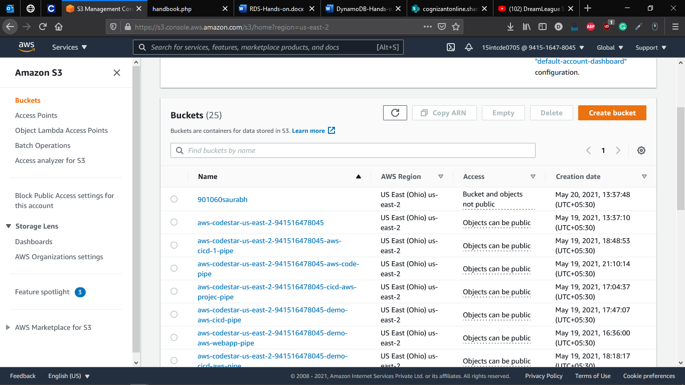

**Uploading Item to S3 Bucket created**

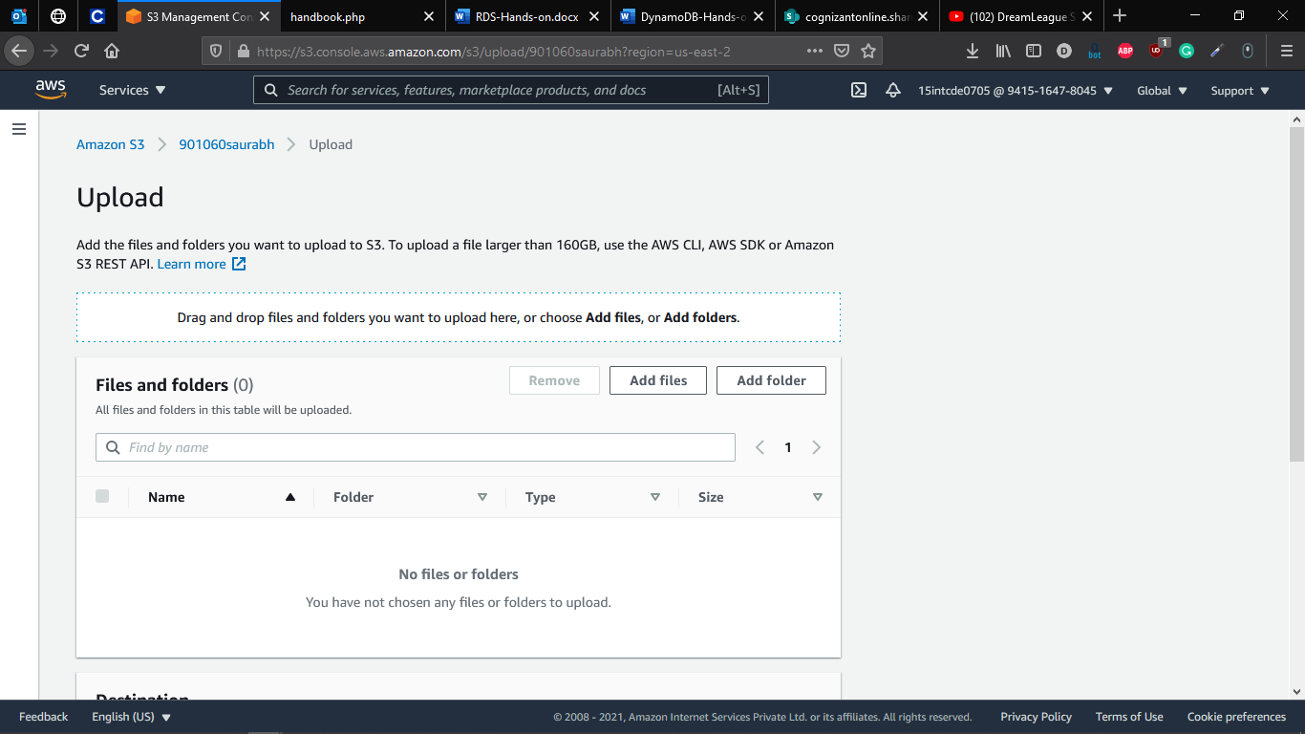

**Items Uploaded Confirmation**

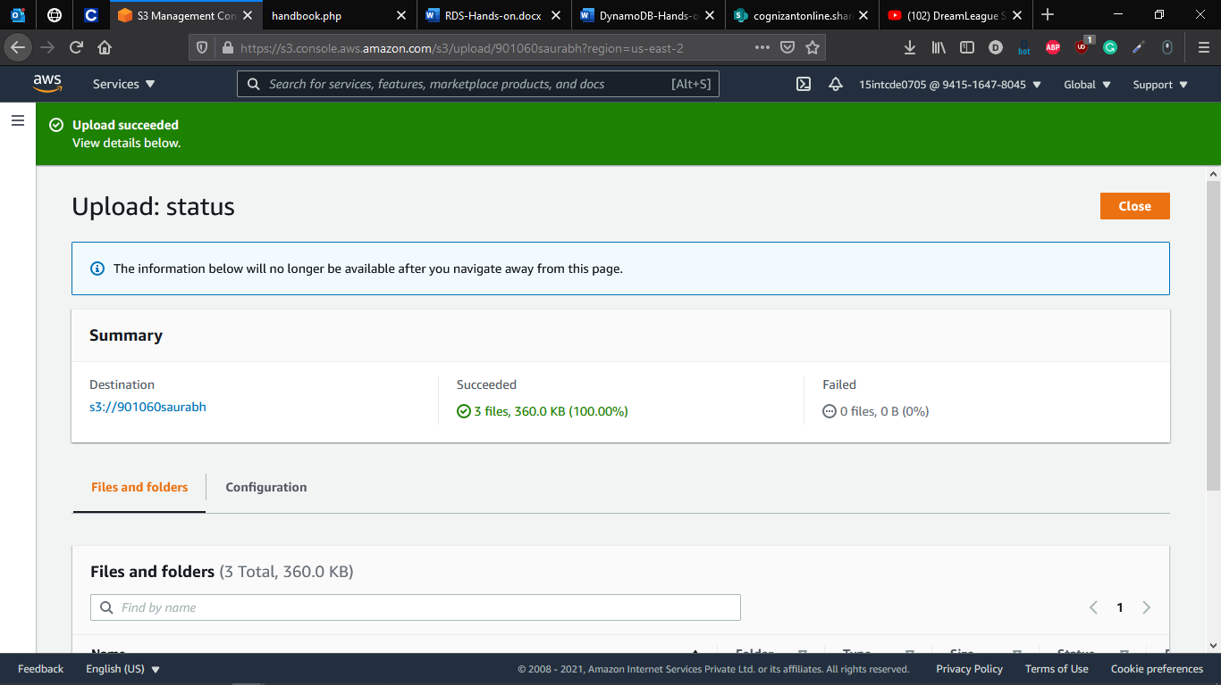

**Making object Public for accessing over web**

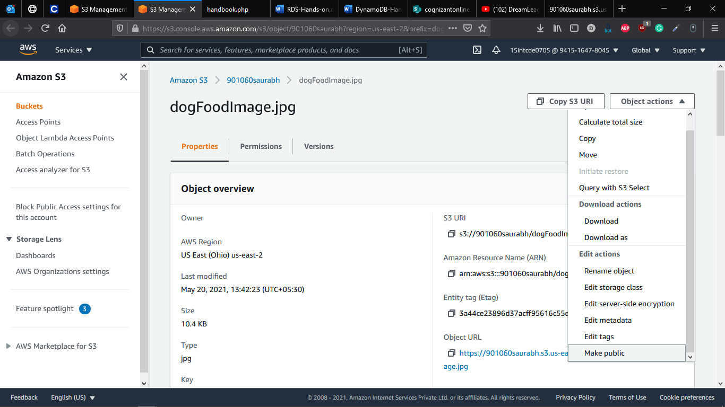

**Accessing the image using the URL provided**

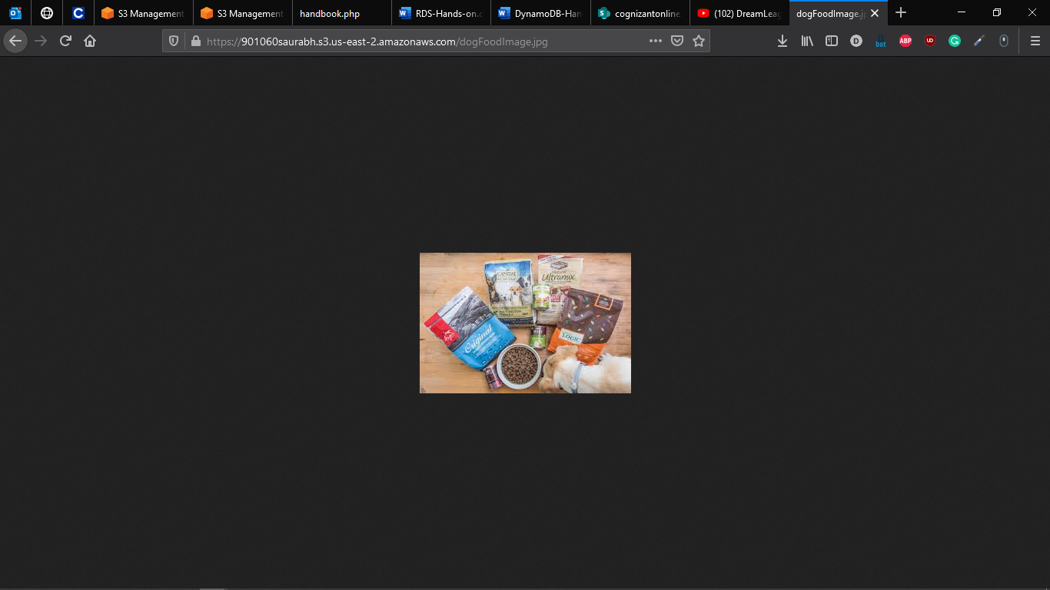

**Removing the Contents of the Bucket**

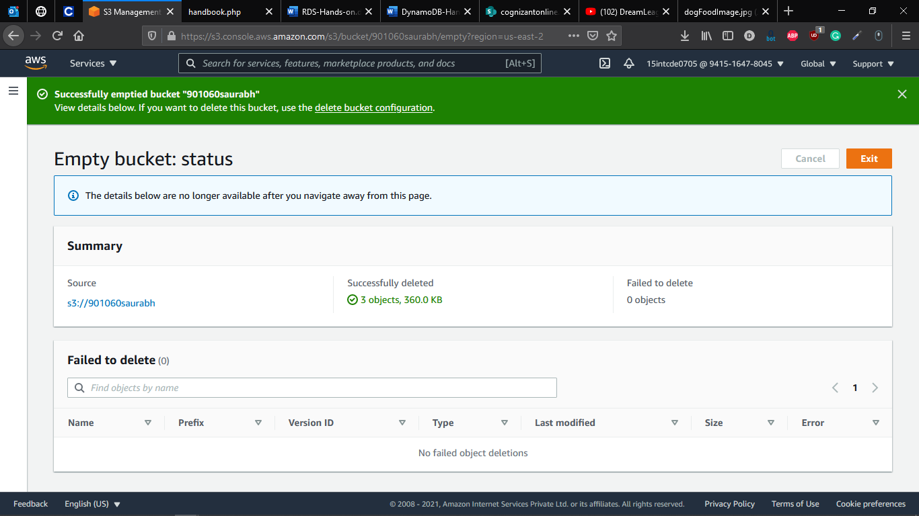

**Deleting the Bucket**

